**Virtual Kitchen Assistant**

Sahim Ahmed

**Table of Contents**

**Introduction………………………………….…………3**

**Feasibility Study………………………………...……3-7**

**Purpose and Scope………………………………….7-10**

**Project Charter…………………………………….10-13**

**Methodology…………………………………….....13-16**

**Stakeholder Criteria………………………....………..17**

**Timeline…………………………………………….18-21**

**Cost Estimation………………………………..…..21-22**

**Resource Definition…………………………….……..23**

**Risk Assessment and Membership……………….23-26**

**Introduction**

Are you a newly graduate student or just recently moved out of your parent’s house, stressing about paying rent, getting a new job, and learning how to live life by yourself. With all this stress already, we don’t want you to stress about something which we all love, food. With the Virtual Kitchen Assistant this will help those who recently moved into their new home and those wanting to enhance their eating routine or even learning how to cook. This AI powered kitchen assistant will help you from preparing your meals, managing inventory, and even provide possible recipe recommendations as well based on your own personal profile.

**Feasibility Study**

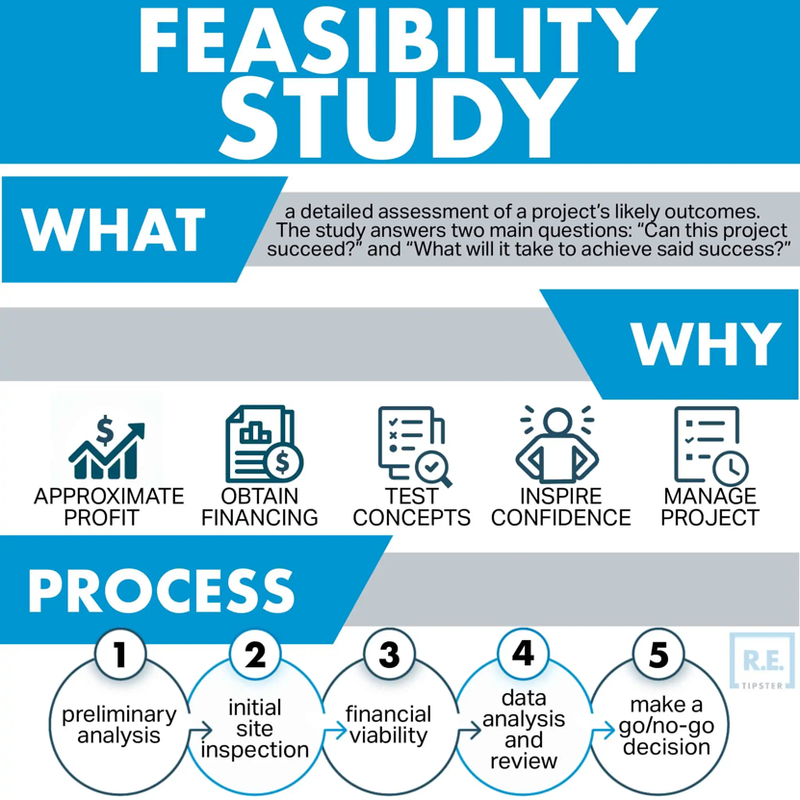

In more recent times especially, near the end of the 2010s and beginning of this new decade, we see a rise in smart devices within our homes and creates a technological harmony of interconnected devices. This study is centered around the development of a Voice Automated Virtual Kitchen Assistant(VKA) which would use voice recognition, AI, and IoT integration similar to already made smart devices like Alexa or the Google assistant. The development of this VKA would help people prepare meals, take care of their kitchen utilities, and process recipes for users as well.

**Market Feasibility**

* **Target group:** people who constantly cook at home, people who are new to cooking, technology savvy individuals, and busy people hoping to cook in a more efficient manner.
* **Marketing Strategy:** we would use social media applications like Twitter, Instagram, TikTok, and etc. to expose our brand to the world. We should also provide our first few models of this new system to popular social media stars on Instagram and TikTok to display our brand to the world as it is more likely the newer generation will be intrigued by this.
* **Need:** due to all the smart home devices that assist people in their everyday task it would be perfect time to start doing the same in a place where people seemingly go to the most

besides their own room. There are certain smart devices like Alexa or the Google assistant that can help generally with kitchen related functions but not to the extent of helping you prepare meals in the actual kitchen.

* **Growth:** the project realizing within the next 3-5 years will be key to the financial growth of the brand and company as smart appliances are at its ever-growing peak right now.

**Technical Feasibility:**

1. **IoT Integration into Smart Appliances**

* the virtual kitchen assistant will be able to connect to various smart kitchen appliances which could also be provided by us as well like ovens, refrigerators, stoves, dishwashers, water filters from the sink, coffee makers, and etc.
* the virtual kitchen assistant once integrated into these kitchen appliances will be able to perform tasks like preheat oven and monitor the cooking status of your meal; smart refrigerators is another example where they will be able to track inventory, scan products that enter the fridge, monitor expiration dates, and etc.
* the virtual kitchen assistant will also be able to remember recipe history or meals made in the past, it will also use this data to recommend other recipes

1. **Voice Recognition:**

* these smart devices with the virtual kitchen assistant will have a natural language processing system incorporated where it will be able to understand voice commands and then performs tasks likewise. An example would be if with your voice you tell your oven

to “set the temperature to 350 degrees and place a timer for 10 minutes starting at 3:30pm”.

1. **Mobile App**

* there will also be a mobile app which will provide users with a visual version of their kitchen smart devices connected through the virtual kitchen assistant where you can visually manage the items in your kitchen, view recommended recipes from your cooking history or based on the item sin your kitchen, and then notifications as well on your appliances.

1. **Cloud Integration:**

* With the incorporation of all the things above a cloud-based system is a must where the virtual kitchen assistant will store all its data and process any data put in it. The system will handle of the cooking history, recipes loaded into the cloud, voice command, and the IoT smart devices through this cloud system.

**Operational Feasibility:**

* **AI and NLP Engineers:** develops the voice recognition system and AI systems to respond and understand commands by voice
* **IoT Engineers:** build framework for the smart appliances and enable connection between the virtual kitchen assistant and the appliances our own to give out to buyers with our virtual kitchen assistant to connect to
* **Smart Appliance Engineers and Developers:**  some smart kitchen appliances could be developed by us which would ensure a bit smoother connection with the VKA and the appliances in relation to smart appliances from other brands.
* **Mobile App Developers:**  design and develop the virtual kitchen assistant app for various platforms
* **Partnership Managers:** enable collaborations with any other smart kitchen appliance corporations and other potential business partners
* **Cloud Infrastructure:** VKA will need a cloud platform to process user voice commands and store data into the cloud of recipes and any other things storedin it

**Financial Feasibility:**

* **Voice Recognition and NLP Development:** up to $3 million
* **IoT Integration:** up to $2 million
* **Smart Kitchen Appliances:** up to $5 million
* **Mobile App:** up to $1 million
* **Marketing:** up to $500k

**Scheduling:**

|  |  |  |  |
| --- | --- | --- | --- |
| **Phase** | **Duration** | **Start Date** | **End Date** |
| **Phase 1: Planning and Research** | **2 months** | **Month 1** | **Month 3** |
| **Phase 2: Designing and Prototyping** | **4 Months** | **Month 3** | **Month 7** |
| **Phase 3: Voice Recognition** | **7 Months** | **Month 7** | **Month 14** |
| **Phase 4: IoT Integration** | **7 Months** | **Month 14** | **Month 21** |
| **Phase 5: App Development** | **4 Months** | **Month 21** | **Month 25** |
| **Phase 6: Testing** | **2 Months** | **Month 25** | **Month 27** |
| **Phase 7: Launch Product and Market to Public** | **1 Month** | **Month 27** | **Month 28** |

**Purpose and Scope**

**Purpose:** The purpose behind this Virtual Kitchen Assistant is to create an innovative, AI- powered kitchen ecosystem for the new generation of adults which will be filled with millennials and people from gen-z. This kitchen assistant will help and enhance the cooking experience for this target audience by providing support in the kitchen with meal preparation, recipe assistance, and kitchen inventory management all through a voice recognition system. With this voice recognition system and integration of IoT to create smart appliances the project will help our audience to have a more efficient cooking environment and empower them to cook effectively, confidently, and with assistance.

**Business and Marketability Value:**

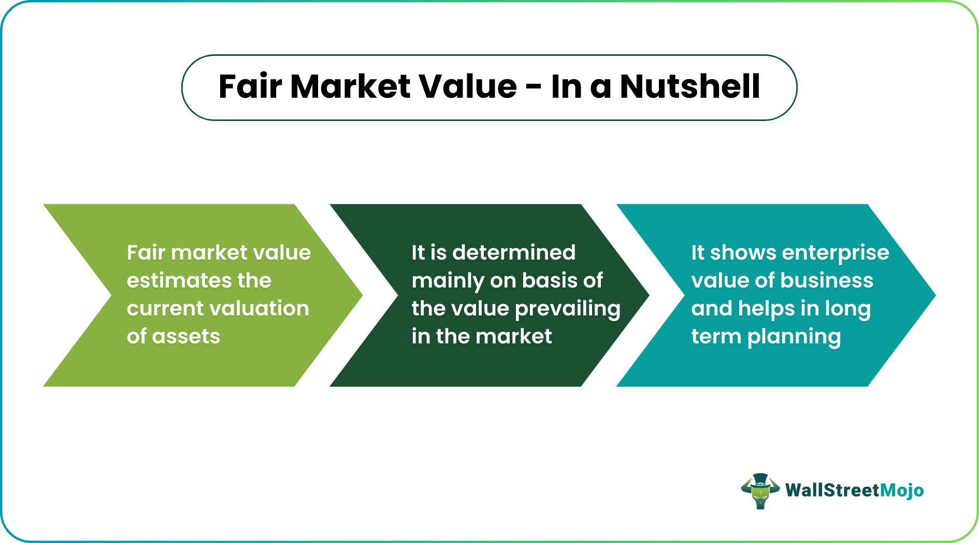

* People of the new generation of adults consist of millennials and gen-z which have both been of the early generations to be exposed to technology from its beginning stages to the point where we can have an entire home with a technical ecosystem.
* The VKA is simply another step towards having a completely technological home ecosystem alongside things like Alexa, google, smart tv’s, and other smart appliances
* Things such as Hello Fresh, Blue Apron, and others have been popular due to the fact that many of the new adults seem to struggle when being in the kitchen, but with VKA it helps users be more comfortable in this environment.
* The voice activation system is an appeal which many people have as it is quick and efficient to the users’ eyes

**Scope:**

The project aims to develop a system where users and the new adults for this generation can gain comfortability in the kitchen and provide an assistant for them in the kitchen. The VKA system with the mobile app will help users have almost full control of their kitchen and it’s inventory, yet still feel as if they are not alone in their cooking journey. The system will first be launched in the United States and eventually make its way to Europe and then worldwide.

* Implement voice recognition and IoT to execute commands in the kitchen and help manage inventory in the fridge
* Provide recipe recommendations with the use of the cloud system which stores the user’s fridge inventory and customizes it based on their preferences of diet
* Mobile app helps users visually view the items in their kitchen that are connected to VKA and see their recipes and ingredients

|  |  |  |
| --- | --- | --- |
| **ID** | **Task** | **Description** |
| 1.0 | Planning | Set the project objectives and finalize the technical needs for project |
| 1.1 | Market Analysis | Watch user demand in market and trends which are seen on social media platforms |
| 1.2 | Team Assembly | Recruit required members and roles which they will play |
| 2.0 | Designing | Create designs for the VKA voice system and the smart appliances that work with it |
| 2.1 | UX/UI Design | Create the mobile app which works with the VKA for in app interactions |
| 2.2 | Prototypes | With the initial foundation which we have perform user testing and receive feedback |
| 2.3 | Backend Architecture Design | Create outline for the structure of AI voice recognition and the smart appliances |
| 3.0 | AI Voice recognition | Build the voice recognition system for the VKA |
| 3.1 | Voice Recognition system | Develop the voice recognition system to perform tasks and commands correlated to what is being said |
| 3.2 | AI Recipe Recognition | Implement an algorithm which creates suggestions by AI on recipes |
| 3.3 | Backend Integration | Connect voice and AI systems to infrastructure for processing work on cloud system |
| 4.0 | IoT Integration and Smart Appliances | Incorporate the VKA with already made smart kitchen appliances and create some of our own |
| 4.1 | API Development | Create API system so the VKA can connect and communicate with the smart appliance properly |
| 4.2 | Inventory Management System | Use software which many clothing stores use to manage inventory of the fridge |
| 4.3 | Device Compatibility Testing | Test the VKA system with various smart kitchen devices to ensure it work properly |
| 4.4 | Collaboration with Smart Appliances | Work with creators of other smart appliances to ensure healthy working business partners |
| 5.0 | Mobile App Development | Build the mobile app to work hand in hand with the VKA system |
| 5.1 | IOS and Android Development | Develop and test the app on both IOS and Android Devices |
| 5.2 | Integration of Voice Recognition in App | Incorporate the VKA voice system and other AI capabilities within app |
| 5.3 | Testing | Test the features of the app and receive feedback for improvements |
| 6.0 | Testing and Iterations | Test the VKA with target audience, iterate feedback, and ensure security |
| 6.1 | User Acceptance Testing | Gather feedback from hand selected individuals and make adjustments as needed |
| 6.2 | Performance and Security | Ensure the VKA system operates securely and without any possible data being leaked out about user’s data |
| 6.3 | Refinements | Make adjustments and resolve any issues found during this porcess |
| 7.0 | Launch and marketing | Launch the VKA to the market and promote it to the target audience |
| 7.1 | Marketing Campaign | Offer the VKA system to social media influencers and have them promote the brand to their followers |
| 7.2 | Product Launch | Release the app and release the product of the VKA with smart appliances bit by bit |
| 7.3 | User Assistance | Create videos, tutorials, and customer support system for easier use of the newly made system |
| 7.4 | Feedback | See the feedback from the initial release and make continuous changes and improvements to the software |

**Project Charter, Phases, and Methodology**

|  |  |
| --- | --- |
| **Project Title:** The Virtual Kitchen Assistant (VKA) | |
| **Project Start Date:** 11/06/2024 | **Project End Date:** 03/17/2027 |
| **Project Purpose:** The purpose of this Virtual Kitchen Assistant is self-explanatory, it is a kitchen assistant, but in the virtual world. With a few simple commands with your voice or via the virtual kitchen assistant app it can help you set up your meals, offer you meal/recipe ideas, and even manage what you have in your fridge inventory. | |
| **Project Aims:**   * Help users gain confidence in the kitchen by giving them a virtual assistant that will guide them through meal preparations * Offer users the option of using the highly advanced voice recognition system to help in the kitchen or use the app which provides just as good service * Help users manage their fridge inventory and provide recommended recipes based on this information | |
| **Project Sponsorship:**  The project sponsor is James Curry; [jcurry@pace.edu](mailto:jcurry@pace.edu) | |
| **Primary Stakeholders:**   1. Sahim Ahmed  * Primary stakeholder, who created the idea and set up the project management foundation for this project  1. Young Adults/Millennials/Gen-Z  * These are the people expected to benefit from this project the most and feedback from them is key to future success of project after initial launch date  1. James Curry  * Project is sponsored and funded through him so that the project is lifted off of paper and into the real world  1. Tech and Engineering team  * They are essential for the development of the VKA system regarding the cloud incorporation, smart devices, and app development | |
| **Financial Plan:**  The project budget allocation is up to roughly $10 million dollars:   * **Voice Recognition and NLP Development:** up to $3 million * **IoT Integration:** up to $2 million * **Smart Kitchen Appliances:** up to $5 million * **Mobile App:** up to $1 million * **Marketing:** up to $500k * **Cloud Maintenance:** up to $50K | |
| **Approach:**   * **Voice Activated System:** system will interpret commands by the user and then perform such kitchen relates tasks * **IoT integration/Recipe Recommendation:** with the IoT integration the VKA AI system will be able to provide recipe suggestions based on dietary restrictions or other factors as well as suggestions based on items in kitchen * **Mobile App:** functional mobile app for IOS or Android users so they can have control with their voice or in app of the VKA system * **Smart Appliance Integration:** while we will make a few smart appliances of our own we will strive to work around with what smart appliances the users may already have which would mean ensuring smooth connectivity of the VKA system to other kitchen smart appliances * **Data Privacy:**  we will ensure that our cloud system for users data is safe and secure with compliance to data privacy regulations for their data and interactions with the system | |
| **Assumptions:**   * User testing participants will provide feedback throughout the project to refine the VKA before the launch date * Other smart appliance brands will look to work or participate in the project by make sure that the compatibility factor works with such smart appliance devices | |

For Sponsor and Stakeholder to sign off for agreement.

|  |  |  |
| --- | --- | --- |
| **Name** | **Signature** | **Date** |
| Sahim Ahmed | Sahim | 11/06/2024 |
|  |  |  |

|  |  |  |  |  |
| --- | --- | --- | --- | --- |
| **Name** | **Impact** | **Priority** | **Importance/Contribution** | **Internal/External** |
| AI and Voice Recognition Engineers | High | High | Responsible for ensuring voice command system works in various kitchen types; like noisy ones | Internal |
| IoT Integration Team | High | High | Ensures the AI features and cloud system are running and work smoothly across various devices | Internal |
| Mobile Developers | High | High | Ensures that the app and VKA system are almost duplicate of one another, so users have smooth control of both | Internal |
| UI/UX Designers | High | High | Ensures the layout of the app is easy to navigate alongside the VKA system | Internal |
| Smart Appliance Manufacturers | Medium | Medium | Ensures that the VKA system works with such devices and tests out the features so that they could be refined later | External |
| Customer Support Team | Medium | High | Works on tutorial videos and guidance for customers and users after the launch date so they can use the system to its maximum capabilities | External |
| User | High | High | Consumer of the product and provides feedback after purchase | External |

**Project Methodology**

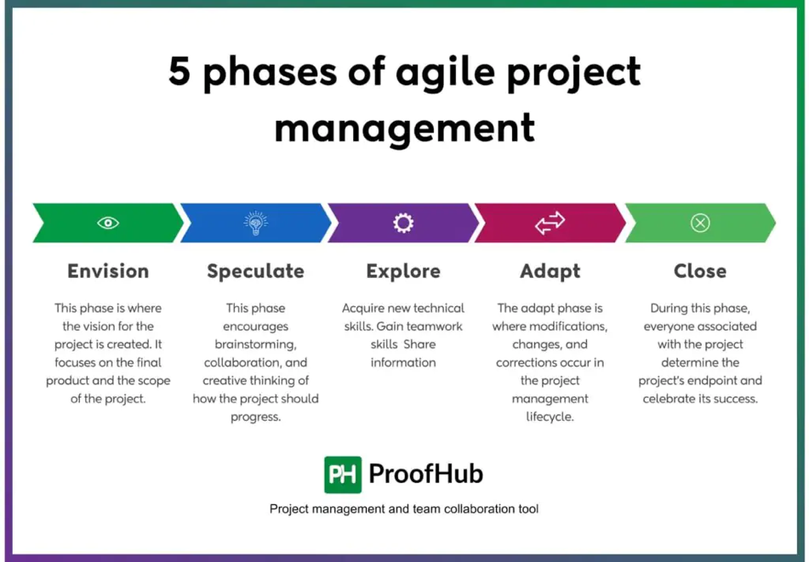

For this Virtual Kitchen Assistant I believe that it is best to go for an Agile project methodology. The reason being is due to the fact that this is more iterative rather than sequential meaning that tasks are often repeated multiple times to gain feedback and analysis on how to make it better. It is also often seen that, and Agile methodology is often used for projects that incorporate product development, software development, or anything else in the IT field which correlates to what we plan on doing with this project. An Agile approach allows us to develop and concentrate on refining important features of our project like the voice recognition, IoT integration, and smart appliances in general. Additionally, since Agile allows a lot of flexibility it helps with this VKA project since it will require a lot of feedback for each step of the process. It is important to use this feedback to make adjustments and better the system as we go. Addressing and discussing technical issues whether it is with the voice recognition, IoT integration or the mobile app development between various team members is key to reducing major risks and setbacks. I feel this would allow better collaboration between the AI engineers, app developers, UX/UI designers, and the software development team as it would allow all aspects of the VKA to be cohesive with one another.

1. **Planning and Marketing**
   * Objective: set project objectives and study trends in the social media realm of things to get a better idea of what users want
   * Process: Go through social media and study needs and desires of our target group on what they would possibly want in their kitchen. Gain inspiration through cooking media content creators and others.
   * Outcome: Create a plan and objectives for our team members to hit while making improvement throughout.
2. **Designing and Protype**
   * Objective: Design and create a prototype of the VKA system based on our market analysis
   * Process: Our AI engineers, UX/UI designers, and software developers would team up to create the system and have a general foundation for the cloud system in store
   * Outcome: Team members are all in line on what they want the VKA system to provide for users and have a cloud system to store the information into
3. **AI Voice Integration**
   * Objective: Design and create the voice recognition system for the VKA
   * Process: software engineers and ai engineers will use knowledge of all the previous and current used voice recognition systems to create one that performs and acknowledges commands from users
   * Outcome: the voice recognition systems is made and will be analyzed by team members for feedback and constant improvements throughout next few phases
4. **IoT Integration**
   * Objective: Develop and finalized the cloud system for the VKA as well as start to create certain appliances from our own company though not main priority
   * Process: software developers and AI engineers more involved and with knowledge on the IoT aspect of things will help make a cloud system for users to store information in and for developers to incorporate so the appliances and the VKA system can communicate with one another properly
   * Outcome: the IoT integration is set, and the cloud system is developed, but will continue to be monitored and refined throughout
5. **Mobile App** 
   * Objective: Develop mobile app that works hand in hand with the VKA system so users have access to a visual version of the system and what they can do
   * Process: UX/UI developers and app developers will collaborate with the engineers of the project to create a system that is functional and work effectively in app as it does with the VKA
   * Outcome: the mobile app will be made and like previous phases it will have refinements if needed
6. **Testing and Refinements**
   * Objective: team members will all come together to put their pieces together for the VKA and will test them out
   * Process: team will test their VKA system by going through real world examples of what the system should be used for or could be used for as well as use hand selected participants to test out the VKA and receive feedback from it
   * Outcome: Final adjustments are made and the ready-made system is ready to launch
7. **Launch and Feedback**
   * Objective: market the VKA system and set the eventual launch day for public to buy
   * Process: Have celebrities market the brand on their social media platforms by giving them free VKA systems to promote and further market it through ads
   * Outcome: Product is launched for the public and we will use the feedback to continuously add features and improve the VKA

**Stakeholder Criteria**

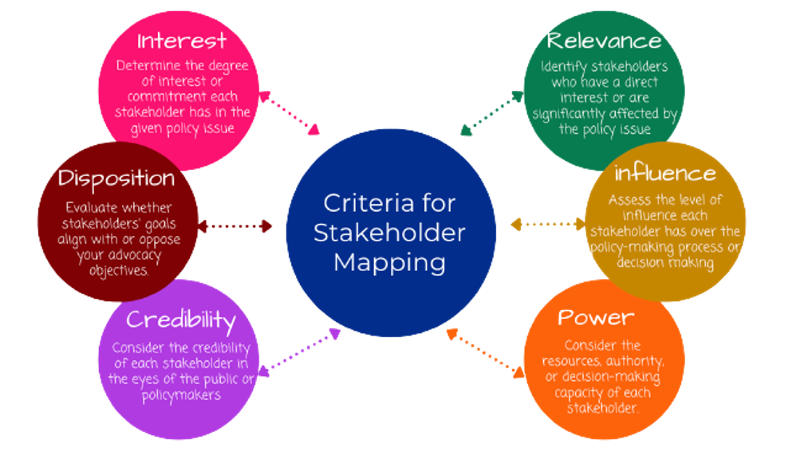

|  |  |  |  |
| --- | --- | --- | --- |
| Stakeholder Group | Overall Project Impact | Influence | Stakeholder Contribution |
| Sahim Ahmed | Medium | High | Provide the project outline and idea so team members can contribute and work on their assigned tasks |
| James Curry | Medium | High | Provided the funding and the green light for this project to take place |
| Young Adults/Millennials/Gen-Z | High | High | Will be the consumers of the VKA system and will help provide feedback on how to make it better for the new versions and updates for this system |
| Tech and Engineering Team | High | High | They are highly essential as they developed the VKA system and any other changes or adjustments for this VKA system will go through them |

**Timeline**

**Resource Definition and Cost Estimation**

**Budget Estimation:** The cost for developing and implementing technology and software for the Virtual Kitchen Assistant will use the $13 million budget. There will roughly be $1.45 million left from the budget given to us if everything goes to plan financial wise. If agreed upon with the sponsors and stakeholders as well as seeing that there is positive response from the users with the Virtual Kitchen Assistant, the remaining budget will be pumped into further advancements and upgrades to future models of the VKA.

* **Total Estimated Budget:** $13 million
* **Distribution of Estimated Budget:** 
  + **Voice Recognition and NLP Development:** $3 million
  + **IoT Integration:** $2 million
  + **Smart Kitchen Appliances:** $5 million
  + **Mobile App: $**1 million
  + **Marketing:** $500,000
  + **Cloud Maintenance:** $50,000
  + **Estimated Excess Budget:** $1.45 million
* **Total Budget Used (Estimate):** $11,550,000
* **Variable Costs (per unit): $**250 (Manufacturing and user support)
  + **Manufacturing and Delivery:** $200
  + **User/Customer Support:** $50
* **Revenue (per unit):** $1,000
* **Predicted Break-Even Point:** 15,400 units

**\*\*** Break Even point is expected between 15,000 – 17,000 Units

**Resource Definition and Allocation:** Resource allocation for the Virtual Kitchen Assistant relates to identifying the needs of the project and then taking steps with the resources acquired to reach to those final steps. This is vital as the tasks and activities incorporated for this project to work requires a multitude of allocated time, finances, and resources. Assuring alignment with the project's budget and schedule, resource allocation will concentrate on allocating these resources throughout the project's many stages, including design, development, testing, and deployment. Although tasks will be completed in a sequential manner, team talks, and cross-departmental collaboration will be scheduled at the conclusion of each phase. These meetings will be used to discuss obstacles, assess progress, and make sure the project's goal is consistent. The project's goal is to produce a top-notch Virtual Kitchen Assistant on schedule and within budget by encouraging teamwork and placing an emphasis on resource efficiency.

* **AI and Voice Recognition Engineers:** (Full Time position) $150,000 salary
* **IoT Integration Engineers:** (Full Time position) $100,000 salary
* **Mobile App Developers:** (Part Time position) $80,000 salary
* **UI/UX Designers:** (Part Time position) $80,0000 salary
* **Smart Appliance Manufacturers:** (Full Time position) $80,000 salary
* **Customer Support Team:** (Part Time position) $50,000 salary

**Risk Assessment and Membership**

An essential part of the Virtual Kitchen Assistant is preparing a risk assessment, which aids in locating and reducing obstacles to the project's success. A team should proactively address doubts before they become serious concerns by methodically examining risks, which might range from technical failures and development delays to user experience difficulties and security vulnerabilities. By setting priorities for activities to address high-impact risks, effective risk assessment guarantees the stability and dependability of the VKA. Regular risk assessments are incorporated into the project to guarantee that the VKA is created resiliently, minimizing setbacks and sustaining progress toward the delivery of a useful, inventive, and user-friendly solution.

**Technical Risks**

|  |  |  |  |  |
| --- | --- | --- | --- | --- |
| **Risk** | **Mitigation** | **Risk Level** | **Responsible role** | **Importance** |
| Software bugs causing incorrect instructions | Thorough testing, QA processes, and regular updates | 3 | VKA Testers | This is to ensure that the product puts out the correct output based on users’ needs |
| Hardware compatibility issues | Compatibility testing with a variety of devices | 3 | Smart Appliance Manufacture Team | This allows the VKA system to be utilized with other smart appliances in the kitchen |

**Operational Risks**

|  |  |  |  |  |
| --- | --- | --- | --- | --- |
| **Risk** | **Mitigation** | **Risk Level** | **Responsible role** | **Importance** |
| User misunderstanding of voice commands | Incorporate AI training with diverse user voices | 5 | AI/NLP Specialist | This is to ensure that the VKA system can understand a various amounts of voice types effectively and in different environments |
| Data loss or unavailability during usage | Cloud backups and offline functionality for critical tasks | 4 | Cloud Infrastructure Team | This is to ensure that the user at all times has access to their data like recipes and inventory |

**Security Risks**

|  |  |  |  |  |
| --- | --- | --- | --- | --- |
| **Risk** | **Mitigation** | **Risk Level** | **Responsible role** | **Importance** |
| Data breaches exposing user information | End-to-end encryption, secure API usage, and regular audits | 5 | Cybersecurity Analyst and Cloud Infrastructure Team | This is to ensure that the users information is secure and not leaked for the public |
| Unauthorized voice access to sensitive actions | Voice authentication and multi-factor verification | 3 | Security Engineer and Voice Recognition Team | This is to ensure that within their homes their isn’t any usage of the VKA system that is not meant to use it (kids) |

**User Experience Risks**

|  |  |  |  |  |
| --- | --- | --- | --- | --- |
| **Risk** | **Mitigation** | **Risk Level** | **Responsible role** | **Importance** |
| Frustration with unresponsive or slow system | Optimized response times | 2 | UX/UI Designer | This is to ensure that we include regular updates to our system software, so users have the best experience possible |

|  |  |  |
| --- | --- | --- |
| **Operation** | **Assigned Individuals** | **Title Roles** |
| Project Management Team | Sahim Ahmed | Project Manager |
| Project Sponsorship | James Curry | Project Sponsor |
| Voice Recognition Team | Jalen Hurts etc., | AI and Voice Recognition Engineer |
| IoT Integration Team | Devonta Smith etc., | IoT Integration Engineers |
| Mobile App Development Team | Saquon Barkley etc., | Mobile App Developers |
| UX/UI Design Team | A.J Brown etc., | UX/UI Designers |
| Smart Appliance Manufacturer Team | Jalen Carter etc., | Smart Appliance Manufacturers |
| Customer Support Team | Quinyon Mitchell etc., | Customer Support |
| VKA Testing Team | Howie Roseman etc., | VKA Tester |